MULTI-DISEASE PREDICTION USING MACHINE LEARNING
(An Intelligent Health Assistant for Diabetes, Heart, Liver and Kidney Risk)
Methodology, Novelty and Key Contributions
Department of Computer Science and Engineering, TKR College of Engineering and Technology (Autonomous)
Batch A3 (CSE-A) · Academic year [ACADEMIC YEAR]
Table 1: Project team
S.No. | Student name | Roll number
1 | AJMEERA HARINI | 23K91A0507
2 | BANDI LIKITHA | 23K91A0526
3 | CHINTHAKINDI SWATHI | 23K91A0555
4 | BADROJU SRI HANSIKA | 23K91A0524

Project guide: B. SRUTHI, Faculty Project Guide, Department of CSE
Chapter and section numbers quoted in the text (for example Section 6.6 or Chapter 8) refer to the full project report, 17.Final Document. Figures and tables in this document are numbered from 1.

1. OVERVIEW OF THE METHODOLOGY
This document describes how the system works from end to end and what is new in it. Part 1 gives the pipeline, the data, the algorithms and the reasons they were chosen; Part 2 sets the work against the base paper and separates what is new from what is standard; Part 3 lists the contributions.
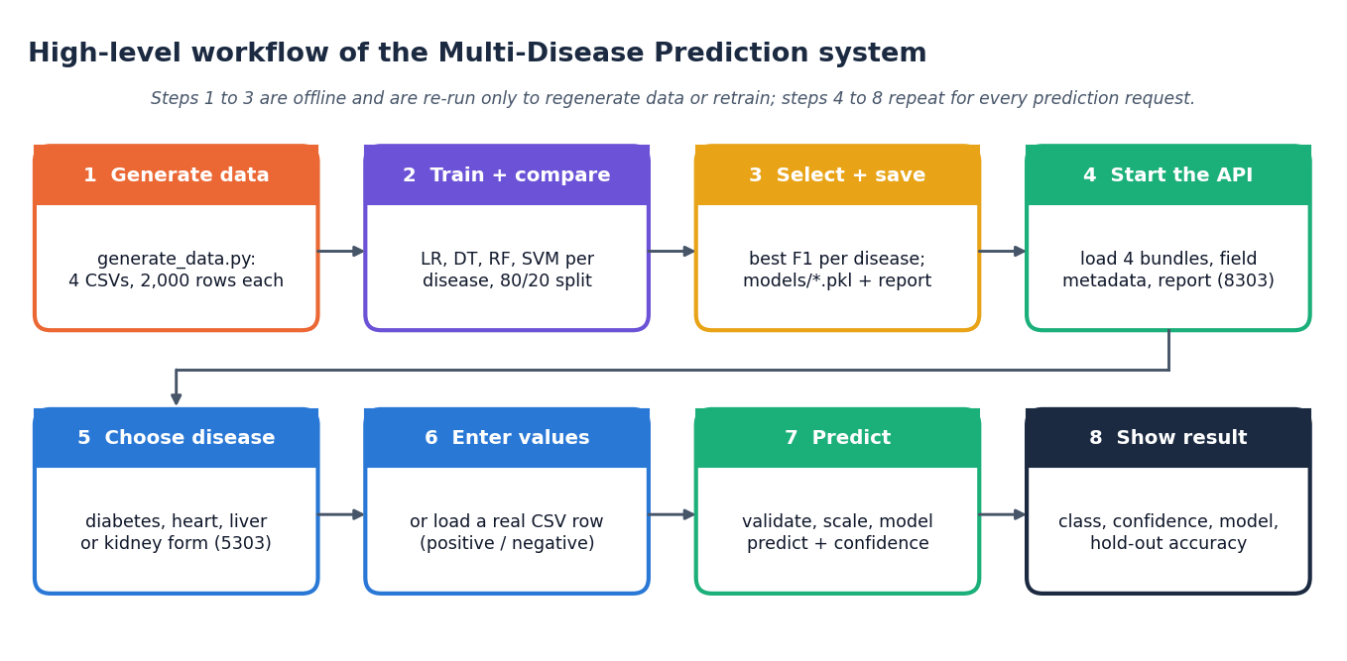
Figure 1: High-level workflow of a prediction in the Intelligent Health Assistant

6.1 Overview of the Methodology
The method is a supervised-learning pipeline repeated independently for four conditions. The first seven steps run once, offline, when the models are built; the last four run for every prediction request.
1. Generate the data. generate_data.py writes four CSV files of 2,000 rows each from the rules of Section 6.2.
2. Read and split. For each disease the CSV is read, the feature columns and the target are separated, and a stratified 80/20 split with random_state=42 gives 1,600 training and 400 test rows.
3. Scale. A StandardScaler is fitted on the training rows only and applied to training and test rows.
4. Train. Logistic Regression, Decision Tree, Random Forest and SVM are fitted with the settings of Section 6.6.
5. Evaluate. Accuracy, precision, recall and F1-score are computed on the 400 test rows.
6. Select. The model with the highest F1 is chosen for the disease.
7. Save. The chosen model, the scaler and the feature list are written with joblib, and the scores of all 16 models are written to training_report.json.
8. Receive a record. At run time the user enters, or loads, one value for each feature of one disease; the form checks that every field is present and numeric.
9. Validate. The API checks the disease key, converts every value to a finite number in the saved feature order and answers 422 or 404 on failure.
10. Scale and predict. The saved scaler transforms the vector; the saved model gives the class and the class probabilities.
11. Report. The class becomes "Positive (High Risk)" or "Negative (Low Risk)", the confidence is the larger class probability, and the model name and its hold-out accuracy are returned with it.
Two things are deliberately absent. The pipeline has no data-cleaning step (the generated data contains no missing values, duplicates or invalid entries, and no imputation or outlier code was written), and it has no explanation step: the application reports a class and a confidence, not the parameters that produced them. Chapter 8 measures what these omissions mean.

6.2 Data: Four Synthetic Datasets
The four datasets are not clinical records. The original build environment had no access to the public benchmark data, so generate_data.py creates data with medically plausible ranges. Each dataset has 2,000 rows (8,000 in total, numpy seed 42), no missing cells and no duplicate rows (checked). The features are drawn independently from the distributions below; the table gives the sampling of each disease.
Table 2: Sampling of the features (generate_data.py)
Disease | Feature distributions
Diabetes | age uniform integer 18-79; pregnancies uniform integer 0-9; glucose N(120, 30) clipped to 60-250; blood pressure N(72, 12) to 40-130; skin thickness N(20, 10) to 0-60; insulin N(80, 60) to 0-400; BMI N(30, 7) to 15-55; pedigree N(0.47, 0.3) to 0.05-2.5
Heart disease | age 29-79; sex, cp (0-3), restecg (0-2), slope (0-2), ca (0-3), thal (0-2) uniform integers; trestbps N(131, 17) to 90-200; chol N(246, 51) to 120-450; thalach N(150, 23) to 70-210; fbs Bernoulli(0.15); exang Bernoulli(0.33); oldpeak exponential(1) to 0-6
Liver disease | age 18-84; gender uniform 0/1; total bilirubin exponential(1.5) to 0.1-20; direct bilirubin = total x U(0.2, 0.6); alk. phosphatase N(290, 150) to 60-1200; ALT exponential(45) to 5-500; AST exponential(50) to 5-500; total protein N(6.5, 1) to 3-9; albumin N(3.2, 0.8) to 1-5.5; A/G ratio = albumin / (protein - albumin + 0.1) to 0.2-3
Kidney disease | age 2-89; blood pressure N(76, 13) to 50-180; specific gravity one of 1.005 ... 1.025; albumin and sugar uniform integers 0-4; random glucose N(148, 70) to 50-490; urea exponential(45) to 10-300; creatinine exponential(1.5) to 0.3-15; sodium N(137, 8) to 110-160; potassium N(4.4, 1) to 2.5-8; haemoglobin N(12.5, 2.5) to 3-18; packed cell volume N(38, 8) to 15-55

The label is then built in three steps. First a linear risk score is computed from some of the features; second the score is passed through the logistic function and the label is 1 if the probability exceeds 0.5 (that is, if the score is positive); third 8% of the labels are flipped at random (add_noise_labels(noise=0.08)).
risk = sum_j w_j (x_j - m_j) + b ; p = 1 / (1 + exp(-risk)) ; y = 1 if p > 0.5 else 0 ; then y is flipped with probability 0.08 (1)
Table 3: Risk score of each disease (the label rule)
Disease | Risk score | Features with no weight
Diabetes | 0.04 (glucose - 120) + 0.06 (BMI - 30) + 0.02 (age - 40) + 1.5 x pedigree + 0.03 (blood pressure - 72) - 1.4 | pregnancies, skin thickness, insulin
Heart disease | 0.035 (age - 50) + 0.9 sex + 0.5 cp + 0.02 (trestbps - 130) + 0.01 (chol - 240) + 0.8 exang + 0.5 oldpeak + 0.6 ca - 0.02 (thalach - 150) - 1.9 | fbs, restecg, slope, thal
Liver disease | 0.35 total bilirubin + 0.02 (alk. phosphatase - 290) + 0.015 (ALT - 45) + 0.01 (AST - 50) - 0.8 albumin + 0.015 (age - 45) - 0.3 | gender, direct bilirubin, total protein, A/G ratio
Kidney disease | 0.02 (age - 45) + 0.02 (BP - 76) - 40 (specific gravity - 1.015) + 0.6 albumin + 0.35 sugar + 0.01 (glucose - 148) + 0.02 (urea - 45) + 0.6 (creatinine - 1.5) - 0.35 (haemoglobin - 12.5) - 1.2 | sodium, potassium, packed cell volume

The positive rate follows from the rule and the distributions: diabetes 40.6%, heart disease 73.1%, liver disease 28.1% and kidney disease 59.8%. Three consequences matter for everything that follows.
• The label is a known linear function of the features plus noise. A linear model is therefore the correct model family, and the accuracy that any classifier can reach on fresh draws is limited to about 92% (one minus the flip rate). A hold-out accuracy of 88-92% means the pipeline recovers the rule almost as well as is possible; it does not say how well the pipeline would detect disease in patients.
• Some features carry no information. Pregnancies, skin thickness and insulin (diabetes), fasting blood sugar, resting ECG, slope and thal (heart), and sodium, potassium and packed cell volume (kidney) have zero weight in the rule, so any model that uses them is fitting noise.
• The features are independent. Real clinical variables are correlated (glucose with BMI, creatinine with urea); here they are not, which removes one of the main difficulties of real data.
Because these data are not a benchmark, a separate supplementary check (scripts/real_data_check.py) was run on public datasets with the same schemas: the Pima Indians Diabetes data [12], the UCI Cleveland heart-disease data [14], the Indian Liver Patient Dataset [16] and the UCI chronic kidney disease data [15]. That check is not part of the application and is reported in Chapter 8.

6.3 Preprocessing
Preprocessing is a single step: standardisation. For every feature j the scaler stores the mean and standard deviation of the 1,600 training rows and maps x to z = (x - mean_j) / sd_j. The scaler is fitted on the training rows only and then applied unchanged to the test rows and, at run time, to the vector entered by the user, so no test information reaches the models and training and serving use the same transformation. The scaler matters for Logistic Regression and the SVM, whose solutions depend on feature scale; trees are unaffected.
Several steps that the project objectives mention were not implemented, and the documents say so plainly: there is no imputation (no value is ever missing in the synthetic data; the real-data check imputes with the median, but the application does not), no outlier detection or capping, no feature selection, no class weighting or resampling (such as SMOTE [23]), and no encoding of categorical variables (the categorical inputs are already coded as small integers by the generator).

6.4 Choice of Algorithms and Why
The four algorithms are the ones the project objectives name. They cover four different ways of drawing a decision boundary, which is why they are a reasonable comparison on tabular data:
Table 4: The four algorithms and the reason each is included
Algorithm | Decision boundary | Why it is in the comparison | Known weakness
Logistic Regression | A single linear boundary in the scaled feature space | The simplest probabilistic baseline; fast, stable and easy to inspect through its coefficients; correct when the label is linear in the features | Cannot capture interactions or non-linear effects unless they are added by hand
Decision Tree | Axis-aligned rectangles from recursive splits | Rule-like and easy to explain; needs no scaling; handles mixed feature types | Unstable and prone to over-fitting; a depth limit is essential
Random Forest | Average of many decorrelated trees [18] | Usually the strongest default on tabular data; reduces the variance of a single tree; gives feature importances | Less smooth than a linear model; can fit label noise when trees are deep
SVM (RBF) | A maximum-margin boundary in a kernel feature space [19] | Flexible non-linear boundary with few parameters; strong on small and medium data | Sensitive to C and gamma; probabilities need an extra calibration step

The project introduction expects ensemble methods to outperform single classifiers on medical tables, and the base paper [1] found Random Forest and CatBoost to be its best classifiers on thyroid data. This project's measurements do not confirm that expectation on its own data: because the labels are linear plus noise, Logistic Regression is as good as or better than Random Forest for all four diseases, and the Random Forest over-fits the noisy labels (Chapter 8). That result is a property of the synthetic data and should not be generalised to clinical data, where the real-data check puts Random Forest and Logistic Regression close together.

6.5 Mathematical Formulation

6.5.1 Logistic Regression
Given a scaled feature vector x, the model estimates the probability of the positive class with the logistic (sigmoid) function of a linear score. Training minimises the L2-penalised log-loss over the n training rows (scikit-learn default, C = 1):
p(y = 1 | x) = sigma(w.x + b) = 1 / (1 + exp(-(w.x + b))) (2)
min over (w, b) of (1/2) ||w||^2 + C * sum_i [ -y_i log p_i - (1 - y_i) log(1 - p_i) ] (3)
The predicted class is 1 when p exceeds 0.5, that is when w.x + b is positive. The coefficients w, measured on standardised features, indicate which inputs raise the risk and by how much.

6.5.2 Decision Tree
A tree chooses at each node the feature and threshold that minimise the weighted Gini impurity of the two child nodes, where for a node with class proportions p_k:
G = 1 - sum_k p_k^2 (4)
Splitting stops at depth 6 (max_depth=6) or when a node is pure. The predicted probability of a leaf is the share of training rows of the positive class in it.

6.5.3 Random Forest
A forest grows B = 200 trees, each of depth at most 8, on bootstrap samples of the training rows, trying a random subset of about sqrt(p) features at every split. The prediction is the average of the trees' class probabilities:
p(y = 1 | x) = (1 / B) * sum_{b = 1..B} p_b(y = 1 | x) (5)

6.5.4 Support Vector Machine
The soft-margin SVM with the radial basis function kernel solves the dual problem below, with C = 1 and gamma = 1 / (p * Var(X)) (gamma="scale"). The decision function is a weighted sum of kernel values at the support vectors:
K(x, x') = exp(-gamma ||x - x'||^2) ; f(x) = sum_i alpha_i y_i K(x_i, x) + b ; 0 <= alpha_i <= C (6)
With probability=True scikit-learn fits a sigmoid (Platt scaling) to the decision values by internal five-fold cross-validation to obtain class probabilities. Because that calibration is fitted separately from the decision function, the class given by predict can occasionally differ from the class with the larger probability.

6.5.5 Evaluation metrics and the selection rule
With TP, FP, TN and FN counted on the 400 test rows (the positive class is "high risk"):
accuracy = (TP + TN) / (TP + TN + FP + FN) ; precision = TP / (TP + FP) ; recall = TP / (TP + FN) (7)
F1 = 2 * precision * recall / (precision + recall) (8)
ROC-AUC is the probability that a randomly chosen positive row receives a higher score than a randomly chosen negative row; it needs no threshold. The training script computes accuracy, precision, recall and F1 only; ROC-AUC was added afterwards in scripts/run_experiments.py. The model served for disease d is the one with the largest F1 on the test rows:
m*(d) = argmax over m in {LR, DT, RF, SVM} of F1_m(d) on the test set (9)
F1 is used instead of accuracy because it penalises both missed cases and false alarms and is not inflated by the majority class. Selecting and reporting on the same test rows gives a slightly optimistic score for the winner [24]; the extra analyses of Chapter 8 (five-fold cross-validation and ten random splits) are the check on that.

6.5.6 Confidence, noise ceiling and permutation importance
The confidence shown to the user is the larger of the two class probabilities, so it lies between 50% and 100% and says how sure the model is of the class it chose; it is not the probability of disease and the models were not calibrated. With a flip rate of 0.08 the best achievable expected accuracy on fresh draws of the synthetic data is 1 - 0.08 = 0.92. Finally, the offline importance analysis shuffles one feature at a time and measures the loss of accuracy:
PI_j = acc(test) - (1 / R) * sum_{r = 1..R} acc(test with column j shuffled in repetition r) , R = 20 (10)

6.6 Model Architecture and Training Configuration
Table 5: Hyper-parameters exactly as used in train_models.py
Algorithm | Constructor | Remaining settings
Logistic Regression | LogisticRegression(max_iter=1000, random_state=42) | L2 penalty, C = 1, lbfgs solver (library defaults)
Decision Tree | DecisionTreeClassifier(max_depth=6, random_state=42) | Gini impurity, no pruning other than the depth limit
Random Forest | RandomForestClassifier(n_estimators=200, max_depth=8, random_state=42) | Bootstrap samples, sqrt(p) features tried per split (library default)
SVM | SVC(kernel="rbf", C=1.0, probability=True, random_state=42) | gamma = "scale"; probabilities by Platt scaling (internal 5-fold cross-validation)

All settings are fixed in the source; no grid search, random search or cross-validation was used to tune them. The training set has 1,600 rows and the test set 400 rows for every disease (stratified, random_state=42); the numbers of positive test rows are 162 for diabetes, 292 for heart disease, 112 for liver disease, 239 for kidney disease. Fitting a single model takes between 3 ms and 0.62 s on the project machine (an Intel Core i5-12500 CPU; no GPU is needed), so the 16 models are trained in a few seconds.
Table 6: Feature counts and the model that is served
Disease | Inputs | Selected model | Selection rule result (test F1)
Diabetes | 8 | SVM | 0.8636
Heart disease | 13 | Logistic Regression | 0.9241
Liver disease | 10 | Logistic Regression | 0.8406
Kidney disease | 12 | Logistic Regression | 0.9027

6.7 Evaluation Protocol
Three layers of evidence are used, each answering a different question. (1) The hold-out test of train_models.py is the number the application shows. (2) Stratified five-fold cross-validation and ten random 80/20 splits (seeds 0 to 9), run by scripts/run_experiments.py with the scaler refitted inside every fold, ask whether the choice of model depends on the particular split. (3) A decision-threshold sweep (0.20 to 0.80), permutation importance, hyper-parameter sensitivity and a train-versus-test comparison characterise the selected models. The extra script also checks that its re-computation reproduces training_report.json exactly, which it does for all 16 model-and-disease cells and for the saved pickles.
The supplementary real-data check uses the same four algorithms and settings with a median imputer in front of the scaler and three repetitions of five-fold cross-validation, and in addition applies the saved, synthetic-trained models to the real records. It is described as supplementary because the datasets, their coding and their size differ from those of the application.
The decisions of the pipeline are summarised in the flowchart below; every box corresponds to a step in train_models.py or backend/main.py.
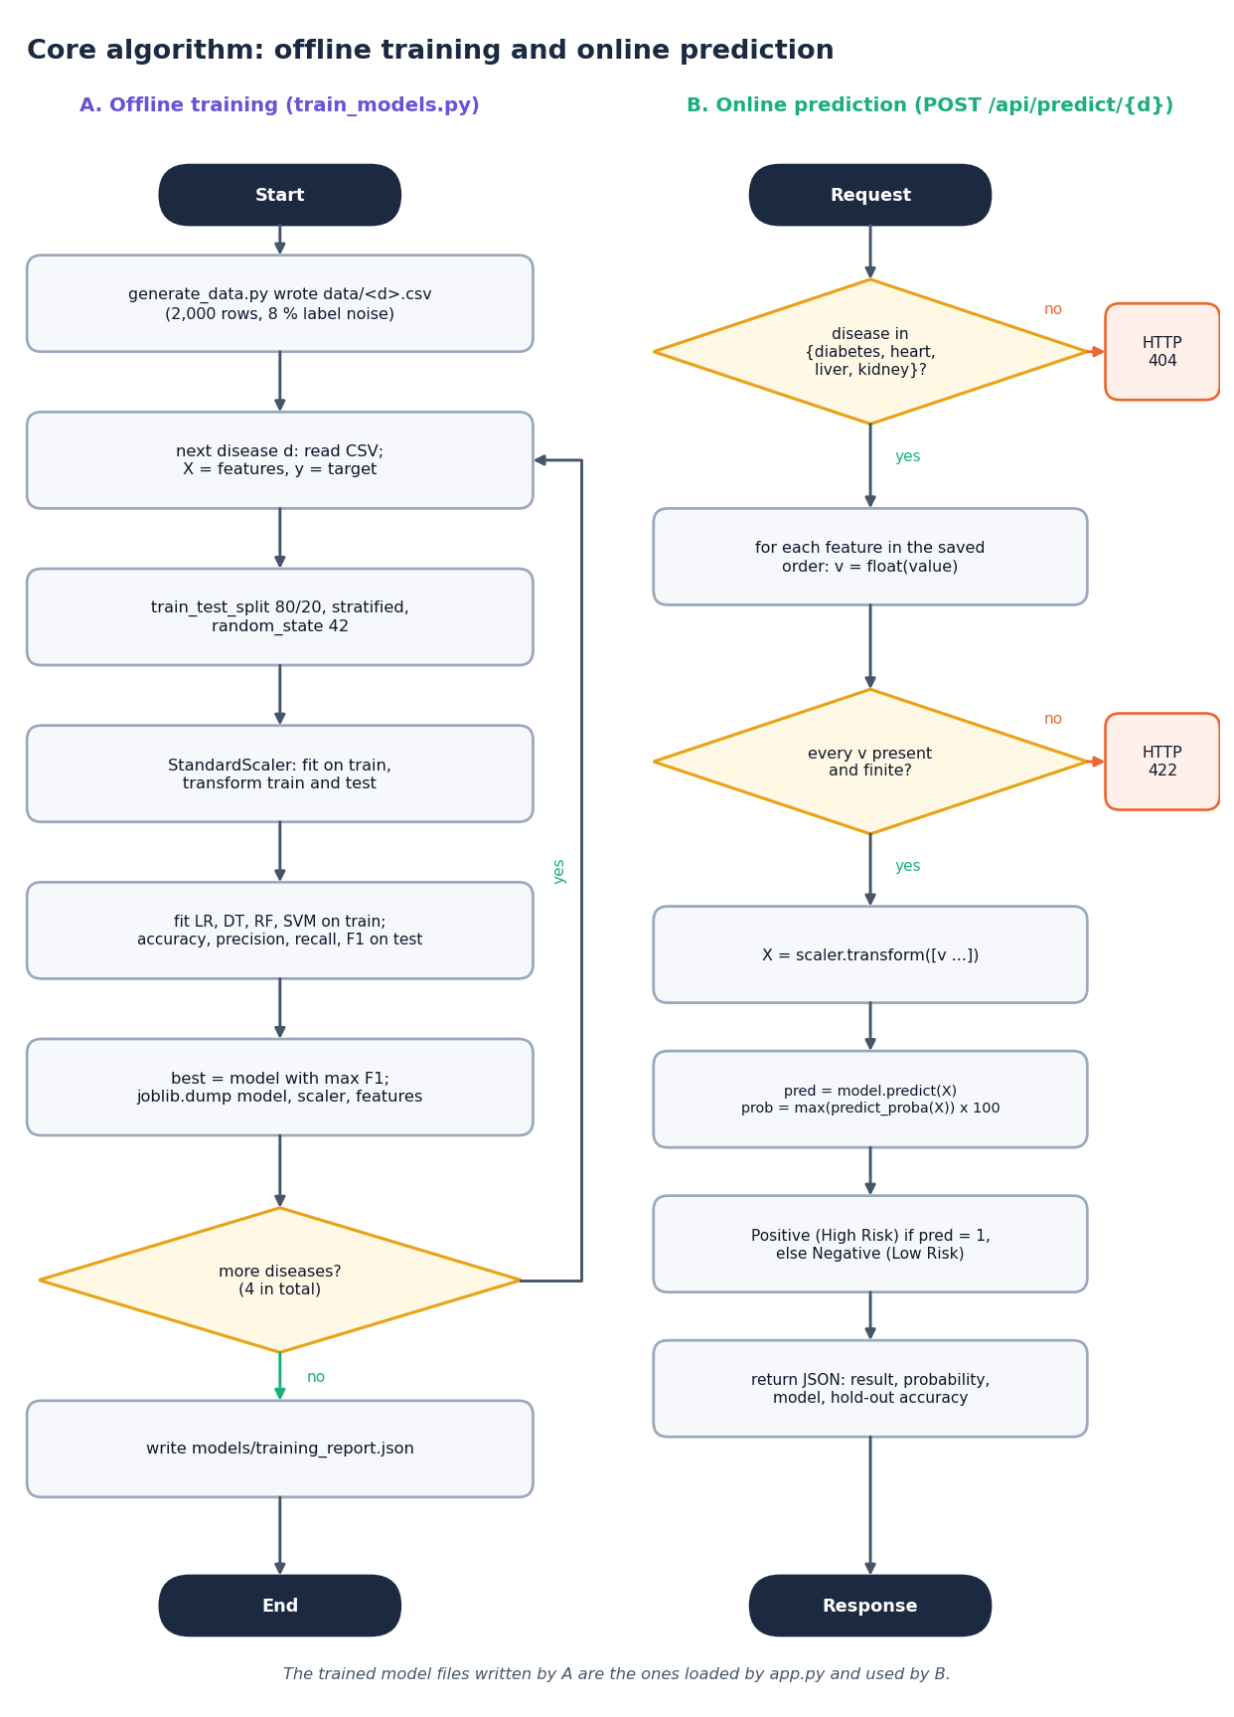
Figure 2: Flowchart of the core algorithm: train, select and serve

2. NOVELTY AGAINST THE BASE PAPER
This section sets the project against the base paper [1] and separates what is new from what is standard. The paper is a single-disease modelling study (thyroid status, real data, nested cross-validation, SHAP and counterfactual explanations); this project is an applied, multi-disease extension of its motivation with a weaker evaluation protocol and no explanations. Its novelty is in the combination and in the audit of its own results, not in a new learning algorithm.
Table 7: Novelty compared with the base paper
Element | Base paper | This project | Status
Scope | One disease: thyroid, three classes | Four diseases (diabetes, heart, liver, kidney) behind one API and one web application | New at application level
Algorithms | SVC, Random Forest, Extra Trees, AdaBoost, CatBoost | Logistic Regression, Decision Tree, Random Forest, SVM from scikit-learn | Standard; no new learner
Preprocessing | Cleaning, feature engineering, consensus top-10 feature selection, scaling inside folds | StandardScaler fitted on the training rows only; no feature selection, no imputation | Standard, simpler
Evaluation | Nested cross-validation, grid search, ROC-AUC, SMOTE study | One hold-out split with fixed settings; cross-validation and ten random splits added as an audit | Weaker protocol, audited
Explainability | SHAP and counterfactual explanations | None in the application; permutation importance offline only | Not achieved; the main gap
Data honesty | Real public data, limits discussed | Synthetic data with a quantified 92% noise ceiling, plus a supplementary real-data check of the shipped models | New in this project
Model-choice robustness | Selection confined to the inner loop | Shows the single-split choice for diabetes is not supported by 5-fold CV and ten splits | New finding
Reproducibility | Fixed seeds, appendix tables | Scripts regenerate every table, chart, screenshot and API test | Good practice applied

What is not new. The four classifiers, standardisation, an 80/20 split, selection by F1, pickled models, a Flask page, a FastAPI wrapper and a React front end are all standard techniques. The synthetic generator follows a familiar idea (a risk score through a sigmoid with label noise). No claim is made that the project improves on the state of the art; the contribution is a working, tested multi-disease interface and an honest account of what its numbers do and do not mean.

3. KEY CONTRIBUTIONS
The project makes six contributions.
1. A single multi-disease screening interface. Sixteen models (four algorithms for each of four diseases) trained by one script and served by a seven-route FastAPI service and a React application with a prediction form per disease, a model-comparison page and a dataset page.
2. An audit of synthetic-data results. The label rule of the generator is analysed to show that about 92% accuracy is the ceiling, and a supplementary run on the Pima, Cleveland, ILPD and chronic kidney disease data shows that the same algorithms score 71.8-98.8% on real data and that the shipped liver model falls below the majority-class baseline.
3. A robustness check of model selection. Five-fold cross-validation and ten random splits show that Logistic Regression is the best model for every disease, and that the SVM shipped for diabetes rests on a single split.
4. A reproducible measurement record. run_experiments.py, real_data_check.py, api_tests.py, make_figures.py and the capture scripts regenerate every number, chart and screenshot in the documents from the project's own files.
5. A tested API. 41 functional, consistency, validation and sanity checks plus a 27-check smoke test pass; the API prediction equals a direct model call on all 40 sampled records, and the latency was measured.
6. An honest comparison with the base paper. The differences in disease, data, protocol and explanations are stated, with no claim to match its metrics, and the gaps (no explanations, no imputation, no ROC-AUC in training, no recommendations) are listed rather than hidden.

